Setup Junit in Intellij

<https://www.jetbrains.com/help/idea/testing.html#create-test-resources-root>

<https://www.jetbrains.com/help/idea/create-tests.html>

1/ Add Junit from Mavern to library

2/ Setup test folder

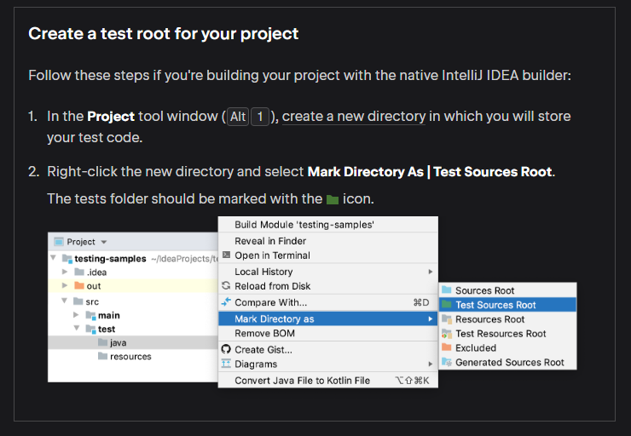

3/ Select the class to be tested and use context menu to create test

Example of a test object

*/\*\*  
 \* Test for methods in Class Circle  
 \* Test for getArea method  
 \*/*public class CircleTest {  
  
 @Test  
 public void getArea() {  
 Circle testCircle = new Circle(10,Colour.*RED*);  
 *assertEquals*(314.159,testCircle.getArea(), 0.1); // expected area is 314.159  
 }  
}